Pathways Academy of Technology & Design
Course Overview
Literature & Composition I: A Survey Course on American Values through Literature
Full Year Course

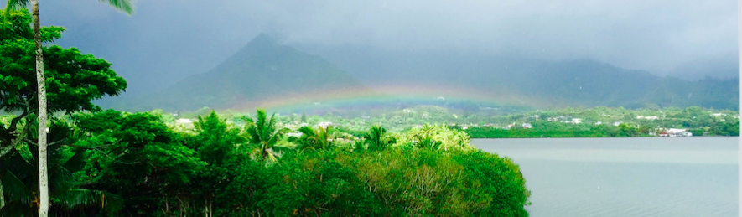

Instructor: | Ms. Chelsea Usher, BA English & Classical Studies from the University of California, Riverside; MS Teacher Leadership from Quinnipiac University
Phone: | 860-695-9527
Email: | Chelsea.Usher@hartfordschools.org
Office Hours: | After school Wednesdays; by appointment
Location: | Room 423
Required Materials needed EVERY class | 3 Ring Binder, College-Lined Paper, Pen/Pencil, Laptop

Course Description: The goal of Lit & Comp I is to refine, apply, and extend the solid foundation of knowledge, skills, and strategies developed in your previous high school English classes. Using the lens of American values, students will develop a new perspective by analyzing classic and contemporary texts in a variety of genres. Students will synthesize information, ideas, and themes to understand the past, the present, and to think innovatively about the future. They will identify and apply their own leadership skills and prepare for responsible action as American citizens in the context of a global world.

Course Outline:

Unit 1: The Power of the Story: Inspiring Passion, Purpose, and Leadership Potential  Anthology of Personal Narratives  Narrative Writing | Unit 2: Shared Responsibility: What does ‘American Culture’ mean?  Excerpts from The New Anthology of American Poetry  Comparison Writing
Unit 3: Maintaining Balance and Integrity: The Responsibility of the Individual  The Crucible  Literary Analysis Writing | Unit 4: Social Responsibility: Redefining the American Dream  The Great Gatsby  Independent Research Paper

Grading Policy:
Participation: This includes regular attendance; preparedness; active and informed contributions to discussion; and respectful engagement with peers. (10%)
Classwork: Any assignments to supplement reading/writing that are to be completed in class. This includes, but is not limited to vocabulary work, notes, verbal participation, informal writing, and project work. Late assignments will not be accepted. (20%)
Tests & Quizzes: Pop quizzes and announced quizzes will focus on understanding for reading and vocabulary. If you missed a quiz, you MUST make it up the next block break for full credit. Tests will test the overall understanding of a unit and will happen much more infrequently. Missed tests must be made up within 3 class days for full credit. (20%)
Projects & Presentations: As a PBL school, projects will be used to assess your learning regularly. These will be graded on use of class time, professional end product, and presentation of ideas. (25%)
Formal Writing: This includes the draft stages, as outlined below. All writing is expected to be in MLA format (Purdue OWL) and properly cited. (25%)

Plagiarism:
Plagiarism is defined as presenting the ideas or words of another as one’s own. It is theft. Disciplinary action in cases of cheating or plagiarism will be handled by and at the discretion of the instructor and, if necessary, in consultation with the behavior technicians. In most cases, individual cases of plagiarism will result in a zero in the assignment, without the option of resubmission. Depending on the nature and the severity of the problem, individual instructors may assign penalties from zero for the assignment to an F in the course.

Late Work Policy:
Work should always be on time. If you have a legitimate excuse for your absence, of course you will have the requisite time to make it up. Otherwise, all work is expected to be complete and submitted on time. As seniors, I expect you to meet your deadlines. Nothing will be accepted late. We all have obligations outside of school; family, work, and even other classes. This will not get any easier as you get older, so you must learn how to properly and effectively manage your time. It’s not an easy task, but you can do it.

Drafts:
All essays will be written in a two-draft stage as outlined below:

Draft 1: a COMPLETE rough draft. This means you have an intro through a conclusion done for submission. You may not have done a complete spelling and grammar check or have cited your sources precisely, but you’ve done the cursory check over (Tools Spelling and Grammar) and you’ve at least attempted to cite the ideas and quotations that are not yours.

Draft 2: a FINISHED version of your rough draft. The difference between done and finished is simple. Done means you’re through with it for the time being. Draft 1 and is DONE when you turn them in. Draft 2 is your final chance to be FINISHED with what you need to say. Your final draft should be error free, peer reviewed, and should have a clear introduction, body, and conclusion. Your citations and citation page should be in order and properly complete.

