Ms. Usher’s English Class
Everything You Need on One Piece of Paper

Room: | 423
Teacher: | Ms. Chelsea Usher
Contact Information: | Chelsea.Usher@hartfordschools.org
Office Hours: | Wednesdays - 2:15-3:15
Homework Policy: | 50% off if it’s late
Class Site: | www.msusher.weebly.com
Every Class You Need: | Pen, Pencil, Paper, Homework, Binder

Essential Questions:  - Who Am I?  - How do Choices I Make Shape Me?  - How do external forces shape my destiny?  - How do I relate to others?  - What Am I Interested in? | Big Goals:  - Demonstrate a critical approach to self  - Apply evidence, reasoning and emotion logically and effectively  - Develop respectful approaches to opposing points of view.

Senior REMIND Sign Up
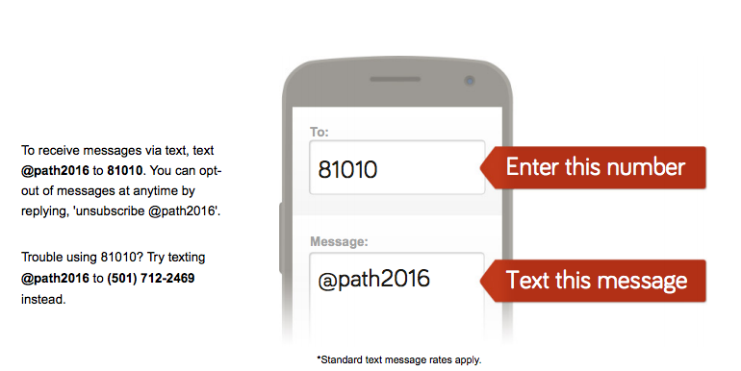
Classroom Rules:
- Come to class prepared with all supplies and homework complete.
- Keep your hands, feet, and objects to yourself.
- Listen when others are talking.
- Participate in class activities.
- Follow directions and all school rules.

Freshmen REMIND Sign Up
